October 2015

Need our Guidance?  Then let Kang Yang be your guide when searching among our huge selection of Card Guides, Ejectors/Pullers and electronics accessories.  Card Guides  PC board accessibility in chassis and rack systems needs to be quick, accurate, safe and reliable to avoid damage to the delicate components on the board. Kang Yang offers a complete range of both vertical and horizontal mount guides with added features available such as tension ribs and capturing pins. Both versions feature proper chamfering for ease of insertion, as well as various color options for network or branding identification.  Do you need Samples? Please ask us!  Do you need more information? Please call us!  Pullers/Ejector arms  Our PCB removal system allows for stress free install or removal of your PCB cards from the chassis and puts all the force on the arm itself instead of your costly PCB assembly. The glass filled Nylon or PC puller/ejector arms have been designed to withstand the increases removal forces associated with high pin count connectors on the backplane or friction due tensioning card guides. Choose from our large selection of standard products or give us your design to make for you instead. | Our new FREE catalog is here!  Our 2015 catalog has grown to include both new product lines as well as additional sizes to offer more choices for cable management, PCB support, LED accessories and more.  What do we offer?  - Proven Quality  - Innovative Products  - Engineering Support  - Solution Focused Approach  - Free Samples  - Unprecedented Service  - Global Presence  Local Support  www.kangyang-usa.com
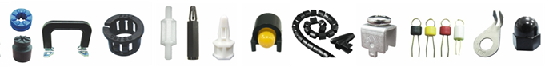
Hanna Lind
10125 Crosstown Circle
Suite 315
Eden Prairie, MN 55344
www.hannalind.com
952-931-1242

